Ministry of education and science of Ukraine
National Technical University of Ukraine
"Kyiv Polytechnic Institute named after Igor Sikorsky"
Educational and Scientific Institute
of Atomic and Thermal Energy

Department of Digital Technologies in Energy

Calculation Graphical Work
credit module:
“Methods of synthesis of virtual reality”

Done by:
Master’s student of 1-st course, ІАТЕ
group TR-42mp
Chervoniak A.B.
Verified by:
Demchyshin A.A.

Kyiv– 2025
Task Description
The Calculation Graphical Work (CGW) assignment focuses on implementing spatial audio using the WebAudio HTML5 API. The primary objectives are to enhance an existing WebGL-based project with immersive audio features and to document the process in a structured report. The specific requirements include:
- Code Reuse: Reuse and adapt code from Practical Assignment #2 (PA2) as the foundation for this task.
- Spatial Audio Implementation: Enable a sound source to rotate around the geometrical center of a surface patch, controlled via a tangible interface (smartphone orientation), while playing a user-selected song in MP3/OGG format.
- Visualization: Represent the sound source’s position with a sphere in the WebGL scene.
- Peak Filter: Integrate a peak filter using the BiquadFilterNode interface, with a checkbox to enable/disable it, and configure filter parameters to enhance specific frequency bands.
- Repository Management: Share the project via a GitHub repository in a branch named CGW, including this report.
- Report: Prepare a digital report with a title page, task description (1 page), theory (2 pages), implementation details (2 pages), user instructions with screenshots (2 pages), and sample source code (2 pages).
This report addresses these requirements, focusing on the Peak Filter variant, and provides a comprehensive overview of the project.

Theory

Understanding Spatial Audio
Spatial audio simulates sound in a three-dimensional environment, creating the perception that audio originates from specific locations around the listener (e.g., front, back, above, or below). Unlike stereo sound, which is limited to left and right channels, spatial audio enhances immersion, making it ideal for virtual reality (VR), gaming, and interactive applications.
Human perception of sound direction relies on cues such as:
- Interaural Time Difference (ITD): The delay between sound reaching each ear.
- Interaural Level Difference (ILD): The difference in sound intensity between ears.
- Head-Related Transfer Functions (HRTFs): Filters that model how sound is altered by the head, ears, and torso, enabling 3D audio simulation over headphones.
Common techniques include binaural audio (for headphones), ambisonics (full-sphere sound fields), and object-based audio (e.g., Dolby Atmos), where sounds are treated as movable objects with positional metadata.

WebAudio API and Spatial Sound
The WebAudio API, part of HTML5, provides a powerful framework for audio processing in web applications. Unlike the basic <audio> tag, it offers a modular audio graph where nodes (e.g., sources, effects, destinations) are connected dynamically. Key components for spatial audio include:
- AudioContext: The core interface for managing audio operations.
- PannerNode: Controls the 3D position of a sound source. It supports:
  - Position (x, y, z coordinates).
  - Orientation (directional sound).
  - Distance models (e.g., inverse, linear) for volume attenuation.
  - HRTF-based spatialization for realistic binaural rendering.
- AudioListener: Represents the listener’s position and orientation, typically aligned with the user’s viewpoint in a 3D scene.
- BiquadFilterNode: Applies audio filters, such as the peak filter, to modify frequency content.

Peak Filter
A peak filter (also called a peaking EQ) is a type of biquad filter that boosts or cuts a specific frequency band without affecting others significantly. It is defined by:
- Center Frequency: The frequency to boost or cut (e.g., 1000 Hz).
- Gain: The amount of boost (positive) or cut (negative) in decibels (e.g., +6 dB).
- Q Factor: The bandwidth of the affected frequencies; higher Q values narrow the range.
In spatial audio, a peak filter can emphasize directional cues (e.g., enhancing mid-range frequencies for clarity) or create artistic effects tailored to the user’s preference. For this project, the filter is toggleable via a checkbox, allowing dynamic control.

Tangible Interface and Quaternions
The tangible interface uses smartphone orientation to control the sound source’s position. Orientation data, often provided as quaternions or Euler angles from accelerometer/gyroscope sensors, represents 3D rotation. Quaternions (w, x, y, z) are preferred in 3D graphics and audio due to their avoidance of gimbal lock and smooth interpolation. These values are mapped to the PannerNode’s position, enabling the sound to orbit the scene’s center based on device movement.

Integration with WebGL
Spatial audio pairs naturally with 3D graphics. Using WebGL (via Three.js or similar), the sound source’s position is visualized as a sphere, synchronized with the PannerNode’s coordinates. This audio-visual linkage enhances user immersion, ensuring that what is heard aligns with what is seen.

Implementation Details
The project builds on Practical Assignment #2 (PA2), a WebGL-based application with a surface patch. The following enhancements were made:

Audio Class Design
An Audio class was developed to handle spatial audio:
- Initialization: Creates an AudioContext and PannerNode. The constructor accepts an audio file path (e.g., "../media/song.mp3") and triggers loading.
- Loading: The fetchAudio method retrieves the file as an ArrayBuffer, decoded into an AudioBuffer using decodeAudioData.
- Playback: The play method sets up the audio graph:
  - A BufferSourceNode streams the audio.
  - A BiquadFilterNode (type: "peaking") connects to the PannerNode, with parameters (e.g., frequency: 1000 Hz, gain: 6 dB, Q: 1) adjustable via a checkbox.
  - The listener is positioned at the origin (0, 0, 0) with a forward orientation (0, 0, -1).
- Position Update: The updatePos(x, y, z) method adjusts the PannerNode’s position based on smartphone orientation.

Tangible Interface Integration
A WebSocket server (using Node.js) receives orientation data from a smartphone app. The main.js script:
Connects to the server at ws://192.168.0.216:8080/sensor/connect?type=android.sensor.game_rotation_vector.
Updates the sound source’s position every 50 ms using setInterval.
Maps orientation (e.g., yaw, pitch, roll) to a circular path around the surface center.
Visualization
In SurfaceModel.js, a sphere is added to the WebGL scene using Three.js. Its position syncs with the PannerNode’s coordinates, updated in the render loop, providing a visual cue for the sound source.

Peak Filter Control
A checkbox in the HTML interface toggles the filter:
When enabled, the BiquadFilterNode connects to the audio graph.
When disabled, it bypasses the filter, routing audio directly to the PannerNode.

Challenges
Coordinate Alignment: Mapping smartphone orientation to 3D space required normalizing sensor data to match WebGL’s coordinate system.
Browser Policies: Audio playback required user interaction (e.g., a button click) to comply with autoplay restrictions.

User Instructions

Setup
- Clone the Repository:
  - Install Git and run: git clone https://github.com/andreeich/VR_Lecture.git
  - Switch to the CGW branch: git switch -c cgw origin/cgw
- Open in VSCode:
  - Launch Visual Studio Code and open the project folder.
- Install Node.js:
  - Download and install Node.js from nodejs.org.
- Run the Server:
  - Open a terminal in the project root and run: node server.js
- Launch the Application:
  - View it in your browser by url: http://localhost:3000.

Interaction
- Sound Source Control: Tilt your smartphone to move the sphere and sound source around the surface center.
- Peak Filter: Check/uncheck the "Enable Peak Filter" box to toggle the filter (boosts 1000 Hz by 6 dB).
- Frustum Adjustments: Use sliders to modify eye separation, FOV, near clipping, and convergence.

Screenshots
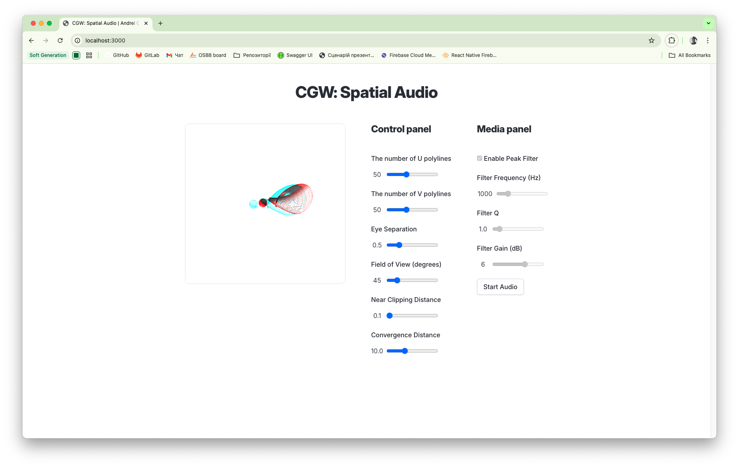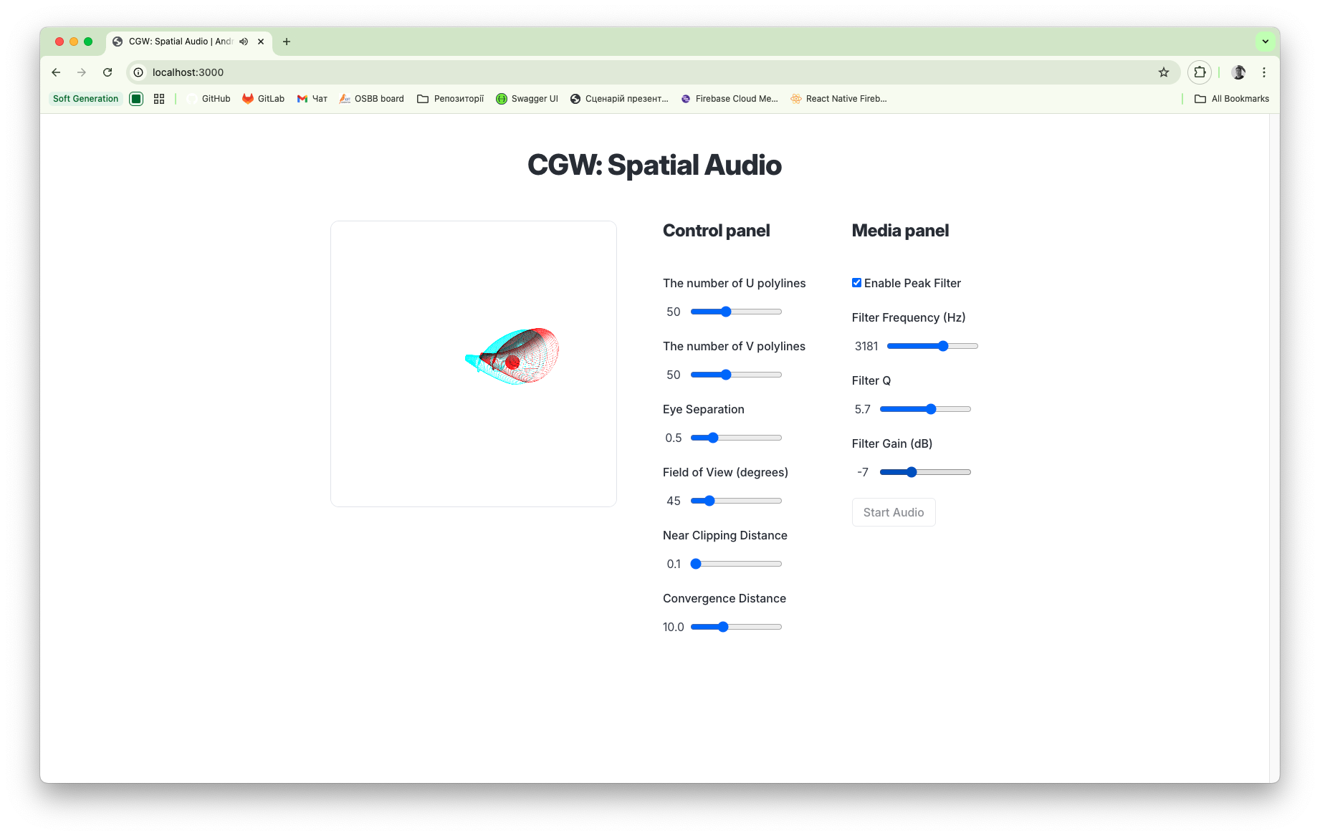

Sample Source Code

audio.js
cexport class Audio {
constructor(fileName) {
this.audioContext = null; // Delay creation
this.panner = null;
this.filter = null;
this.source = null;
this.useFilter = true;
this.fileName = fileName;
}

async start() {
// Create AudioContext after user gesture
if (!this.audioContext) {
this.audioContext = new AudioContext();
this.panner = this.audioContext.createPanner();
this.filter = this.audioContext.createBiquadFilter();

// Configure panner
this.panner.panningModel = "HRTF";
this.panner.distanceModel = "inverse";
this.panner.refDistance = 1;
this.panner.maxDistance = 100;
this.panner.rolloffFactor = 1;

// Configure peak filter
this.filter.type = "peaking";
this.filter.frequency.setValueAtTime(1000, this.audioContext.currentTime);
this.filter.Q.setValueAtTime(1.0, this.audioContext.currentTime);
this.filter.gain.setValueAtTime(6, this.audioContext.currentTime);

// Set listener position and orientation
const listener = this.audioContext.listener;
listener.positionX.setValueAtTime(0, this.audioContext.currentTime);
listener.positionY.setValueAtTime(0, this.audioContext.currentTime);
listener.positionZ.setValueAtTime(0, this.audioContext.currentTime);
listener.forwardX.setValueAtTime(0, this.audioContext.currentTime);
listener.forwardY.setValueAtTime(1, this.audioContext.currentTime);
listener.forwardZ.setValueAtTime(0, this.audioContext.currentTime);
listener.upX.setValueAtTime(0, this.audioContext.currentTime);
listener.upY.setValueAtTime(0, this.audioContext.currentTime);
listener.upZ.setValueAtTime(1, this.audioContext.currentTime);
}

// Resume AudioContext if suspended
if (this.audioContext.state === "suspended") {
await this.audioContext.resume();
console.log("AudioContext resumed");
}

// Fetch and play audio
await this.fetchAudio(this.fileName);
}

async fetchAudio(fileName) {
try {
const response = await fetch(fileName);
const arrayBuffer = await response.arrayBuffer();
const audioBuffer = await this.audioContext.decodeAudioData(arrayBuffer);
this.play(audioBuffer);
} catch (error) {
console.error("Error loading audio file:", error);
}
}

play(audioBuffer) {
this.source = this.audioContext.createBufferSource();
this.source.buffer = audioBuffer;
this.source.loop = true;
this.source.connect(this.panner);
this.updateRouting();
this.source.start();
}

updatePos(x, y, z) {
if (this.panner) {
this.panner.positionX.setValueAtTime(x, this.audioContext.currentTime);
this.panner.positionY.setValueAtTime(y, this.audioContext.currentTime);
this.panner.positionZ.setValueAtTime(z, this.audioContext.currentTime);
}
}

setFilterFrequency(value) {
if (this.filter) {
this.filter.frequency.setValueAtTime(
value,
this.audioContext.currentTime,
);
}
}

setFilterQ(value) {
if (this.filter) {
this.filter.Q.setValueAtTime(value, this.audioContext.currentTime);
}
}

setFilterGain(value) {
if (this.filter) {
this.filter.gain.setValueAtTime(value, this.audioContext.currentTime);
}
}

enableFilter(enabled) {
this.useFilter = enabled;
this.updateRouting();
}

updateRouting() {
if (!this.panner || !this.source) return;

try {
this.panner.disconnect();
} catch (e) {
// Ignore if not connected
}

if (this.useFilter) {
this.panner.connect(this.filter);
this.filter.connect(this.audioContext.destination);
} else {
this.panner.connect(this.audioContext.destination);
}
}
}

main.js
function initSensorWebSocket() {
const wsUrl =
"ws://192.168.0.216:8080/sensor/connect?type=android.sensor.game_rotation_vector";
sensorSocket = new WebSocket(wsUrl);

sensorSocket.onopen = () => {
console.log("Connected to Sensor Server WebSocket");
};

sensorSocket.onmessage = (event) => {
const data = JSON.parse(event.data);
if (data.values && data.values.length >= 4) {
// Sensor data: [x*sin(θ/2), y*sin(θ/2), z*sin(θ/2), cos(θ/2)]
// Reorder to [w, x, y, z] for quaternionToMatrix
const quaternion = [
data.values[3],
data.values[0],
data.values[1],
data.values[2],
];
// console.log("Quaternion:", quaternion); // Debug: verify order
orientationMatrix = quaternionToMatrix(quaternion);
}
};

sensorSocket.onerror = (error) => {
console.error("WebSocket error:", error);
};

sensorSocket.onclose = () => {
console.log("WebSocket closed. Attempting to reconnect...");
setTimeout(initSensorWebSocket, 5000);
};
}

SurfaceModel.js
createSphereData(radius) {
const segments = this.uSteps; // Reuse uSteps, vSteps for sphere resolution
const vertices = [];
const triangles = [];

for (let lat = 0; lat <= segments; lat++) {
const theta = (lat * Math.PI) / segments;
const sinTheta = Math.sin(theta);
const cosTheta = Math.cos(theta);

for (let lon = 0; lon <= segments; lon++) {
const phi = (lon * 2 * Math.PI) / segments;
const sinPhi = Math.sin(phi);
const cosPhi = Math.cos(phi);

const x = radius * sinTheta * cosPhi;
const y = radius * sinTheta * sinPhi;
const z = radius * cosTheta;

vertices.push({
position: [x, y, z],
normal: [x / radius, y / radius, z / radius],
});
}
}

for (let lat = 0; lat < segments; lat++) {
for (let lon = 0; lon < segments; lon++) {
const first = lat * (segments + 1) + lon;
const second = first + segments + 1;

triangles.push([first, second, first + 1]);
triangles.push([second, second + 1, first + 1]);
}
}

this.vertices = new Float32Array(vertices.length * 3);
this.normals = new Float32Array(vertices.length * 3);
this.indices = new Uint16Array(triangles.length * 3);

vertices.forEach((v, i) => {
this.vertices[i * 3] = v.position[0];
this.vertices[i * 3 + 1] = v.position[1];
this.vertices[i * 3 + 2] = v.position[2];
this.normals[i * 3] = v.normal[0];
this.normals[i * 3 + 1] = v.normal[1];
this.normals[i * 3 + 2] = v.normal[2];
});

triangles.forEach((t, i) => {
this.indices[i * 3] = t[0];
this.indices[i * 3 + 1] = t[1];
this.indices[i * 3 + 2] = t[2];
});

this.vertexCount = vertices.length;
this.indexCount = triangles.length * 3;
}

Conclusion
This report documents the CGW task on Spatial Audio with a Peak Filter variant. It integrates theoretical concepts (spatial audio, WebAudio API, peak filters, quaternions) with a practical implementation, reusing PA2 code and adding a tangible interface, visualization, and filter control. The result is an immersive web application, fully documented and accessible via the CGW branch of the GitHub repository.

